Multistage dockerfile assignment

Create dockerfile

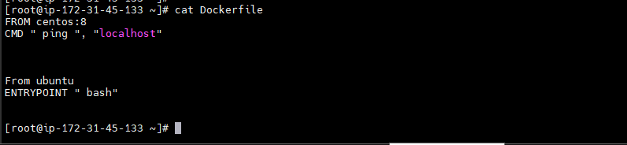

Build the dockerfile and see the image

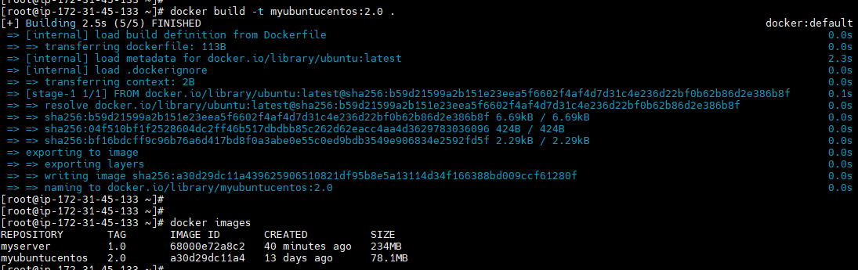

Run the dockerfile and container is created and exited

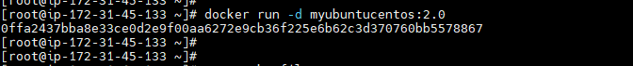

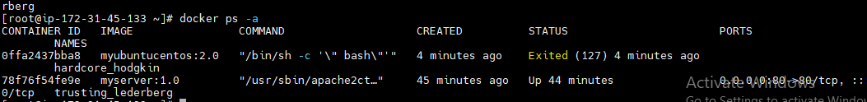

From internet2)

Create dockerfile

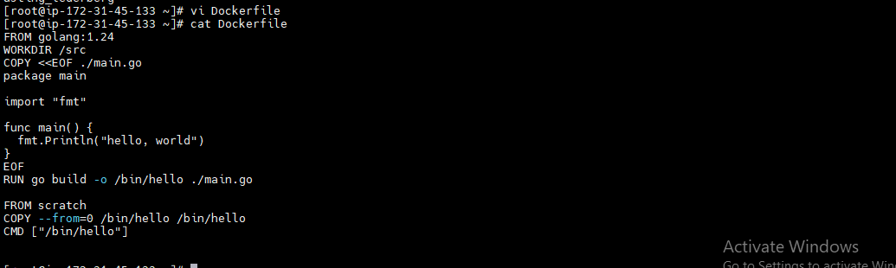

Build the docker file

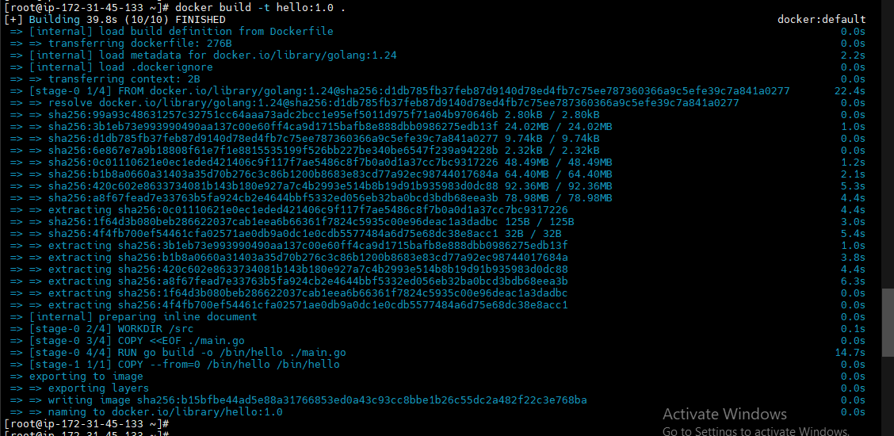

Image is created :- (hello)

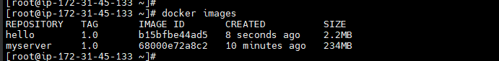

Run the dockerfile and container is created and exited

